User Guide 28 Objection Management
Purpose of this User Guide
The purpose of this User Guide is to assist Responsible Authorities in the management of objections to planning permits.
Who should read this guide?
Primary audience: Responsible Authorities
For Information: VCAT and Objectors
Introduction
Responsible Authorities and VCAT are responsible for sending advice and notices to objectors and other parties for VCAT Applications for Review. Currently, a Responsible Authority user that is responsible for sending notices must check both on SPEAR for objections lodged by self-registered objectors and offline for objections raised by mail or over the counter.
SPEAR allows a Responsible Authority user to load offline objections into SPEAR and to then create and populate the Decision to Grant Enquiries form online.
28.1 Viewing Objections
SPEAR users (applicants, Responsible Authorities, referral authorities, VCAT) that are associated with the application and having the appropriate level of access can view all current objections (whether supplied by self-registered objectors, or entered on behalf of objectors by the Responsible Authority) for an application by opening the ‘Objectors’ section from the Details tab.
Registered Objectors can view a list of objections (whether supplied by self-registered objectors, or entered on behalf of objectors by the Responsible Authority) from the Objections tab.
28.2 Who can Manage Objections
Responsible Authority users need to have their SPEAR user profile modified to change to the ‘3rd Party Objector / Responsible Authority’ role. This task can be performed by the Responsible Authority Local Administrator.
28.3 Manage Objections
To add objections, the Responsible Authority user must change role to ‘3rd Party Objector / Responsible Authority’.
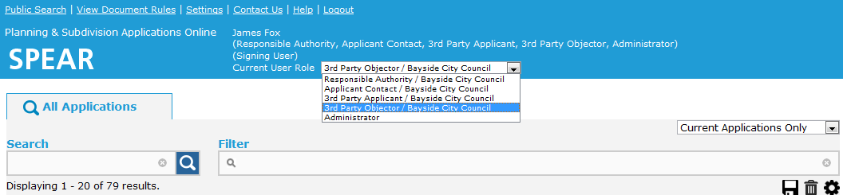
Select the drop-down list from the banner to change roles. Refer to screen below.

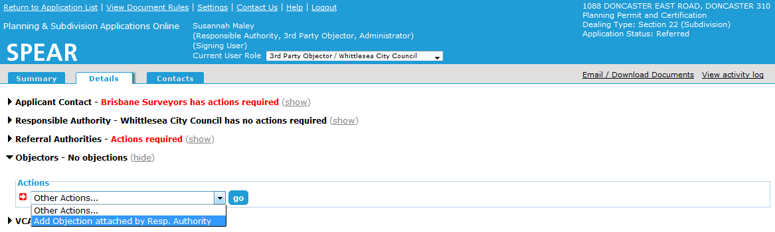
As a 3rd party Objector / Responsible Authority you will now have the optional action to ‘Add Objection attached by Responsible Authority’. Select this option to enter details of objections.

When selecting the optional action ‘Add objection attached by Resp. Authority’ the user will be presented with the following screen to enter objector contact details and either enter free text or attach a file, such as the original written objection.

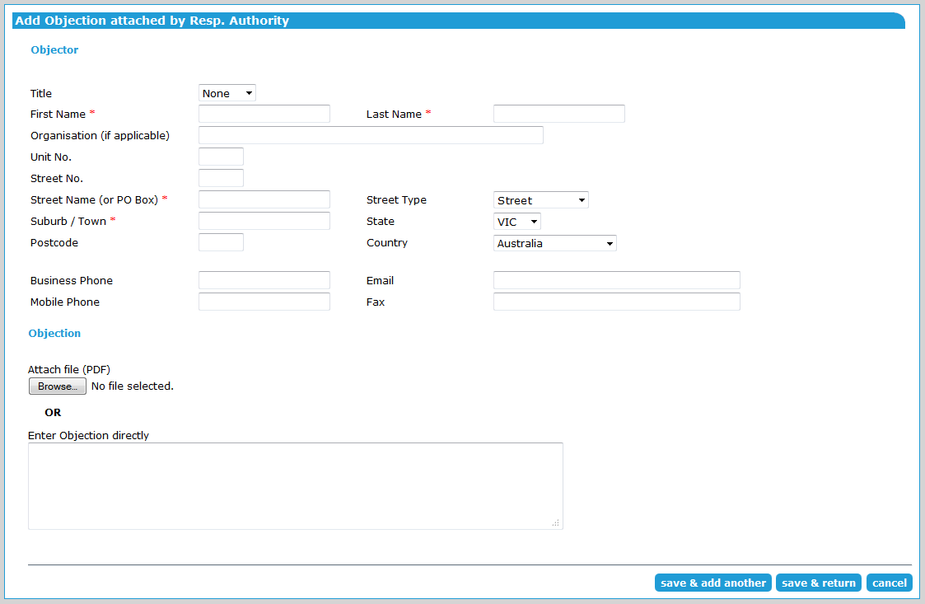
Once the Responsible Authority user has added all the details, the user will have the option to ‘save & add another’ where the details will be stored, and the user will be presented with a new Add Objection screen, or ‘save & return’ when they have completed adding objector details, and want to return to the Details tab.
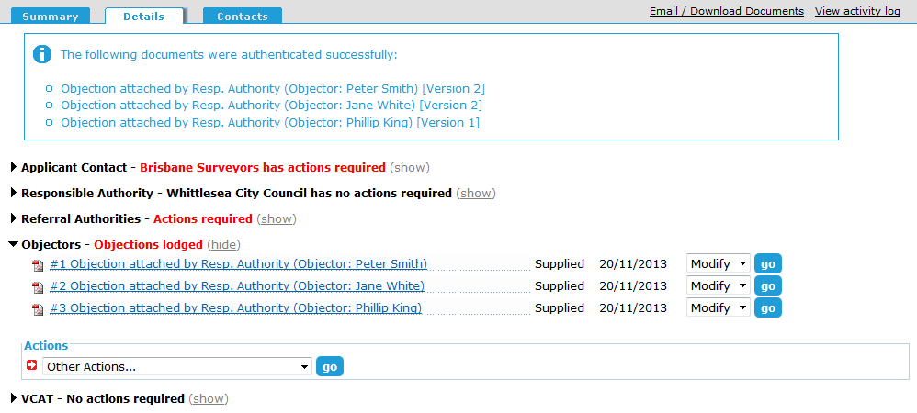
SPEAR will confirm the action. The Responsible Authority user will then need to change roles back to ‘Responsible Authority’ to continue in SPEAR.

28.4 Modify or Withdraw Objections
Responsible Authority users can use the ‘Modify’ action to change the details for objections previously entered by them. The Manage Objections screen now includes a section at the bottom for ‘Withdrawal of Objections’ and an ‘update’ button.
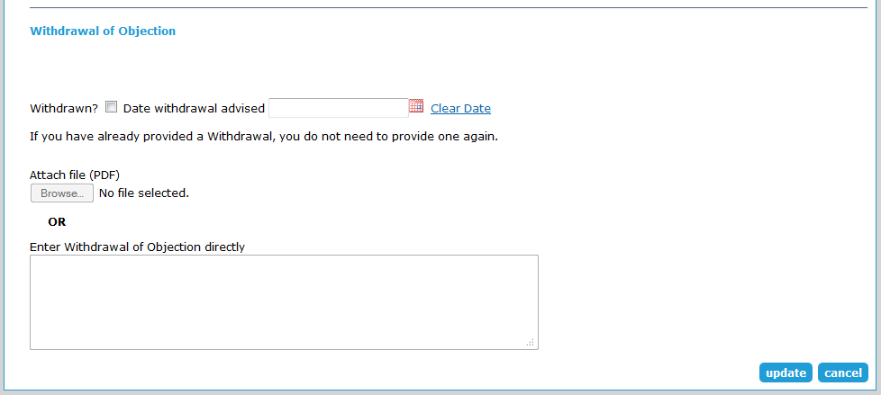
Need more information?
Further information on this topic can be found by:
- Contacting the SPEAR Service Desk on (03) 9194 0612 or email spear.info@delwp.vic.gov.au
- Referring to User Guide 47 - Preparation of Decision to Grant Enquiry Form.

